EMERGENCY MANAGEMENT PLAN
2024

Created: June, 2022 Finalized and Posted: July 11 2023
Revised: July 2022 Reviewed: January 2024

Contents
I. Authorization 4
II. Interim Plan Revisions 6
Section 1 – Emergency Plan Administration 7
1.1 Executive Summary 7
1.2 Purpose 7
1.3 Scope 8
1.4 Emergency Management Committee 8
Section 2 - Situation and Assumptions 10
2.1 Hazard Vulnerability Analysis 10
2.2 Key Plan Assumptions 10
Section 3 - Command and Control 12
3.1 Incident Command System 12
3.2 Authority to Activate 13
3.3 Incident Activation & Deactivation 14
3.4 Deactivation 14
3.5 Information Collection, Documentation, Analysis, and Dissemination 14
3.6 Roles and Responsibilities 14
Section 4 - Continuity of Operations 16
4.1 Essential Functions 16
4.2 IPAC Program 16
Section 5 - Communications 18
5.1 Risk Communications 18
5.2 Staff and Resident/Tenant Notifications 18
5.3 Communications with Partners 19
Section 6 - Buildings, Utilities, Safety and Security 20
6.1 Facilities Management 20
6.2 Evacuation Planning /Shelter-in-Place Plans 20
6.3 Utility Mapping 20
Section 7 – Emergency Operations Centre (EOC) 20
7.1 EOC Set-up 20
7.3 Volunteer Management 21
7.4 Staff Scheduling and Care 21
Section 8 - Community Integration 21
8.1 Identification of Planning and Response Partners 21
Community Partnering 21
8.2 Agreements 21
8.3 Emergency Mental Health 22
Section 9 - Plan Development and Maintenance 22
9.1 Plan Development, Review, and Storage 22
9.2 Training, Exercises, and Evaluation 23
9.3 Extreme Weather Events 24
9.4 Boil Waters Advisories 25
APPENDIX A – HVA 26
APPENDIX B – IPAC Program 27
APPENDIX (C) – IMS Assignment List and Instructions for IMS Activation 30
Instructions for IMS (EOC) Activation 30
APPENDIX (D) – Instructions for Using Emergency Voice Communication Systems (Fire Panel) 31
Step 1- Upon Hearing the Fire Alarm 31
Step 2- Acknowledge the fire alarm 32
Step 2- Find the exact location of the Fire Alarm from the fire panel 32
Step 3 - Making an Announcement at Faith Manor 33
If the incident is a Confirmed Emergency by the Charge RN/RPN/Fire Department/Facilities Staff 34
Step 4 - Resetting the Fire Alarm System 36
RESET ONLY WITH THE PERMISSION OF THE FIRE DEPARTMENT 36
If the Fire Panel Does Not Reset 37
Step 5 - Resetting the Maglocks 37
Step 6 - Resetting the Elevators 38
APPENDIX (E) – Emergency Codes 39
APPENDIX (F) – STAFFING PLAN POLICY 40
APPENDIX (G) – Staff Contact List 49
APPENDIX (H) – Sample Supply List for Holland Christian Homes EOC Below is a sample list of items needed to activate the Command Center/EOC location: 50
Communication Equipment 50
Electronic Equipment 50
Food and Water 50
Reference and Resource Materials 50
Furniture 50
Office Supplies 50
Safety Equipment and Supplies 50
Personal Protective Equipment (PPE) 50
APPENDIX (I) – Sample Vendor Contact List 51
APPENDIX (J) - Sample Multi-year Training and Exercise Plan 52

Authorization

The following leadership agrees to support and uphold the Holland Christian Homes Emergency Management Plan.
Name | Robert Marcinkiewicz
Title | Director of Facilities

Name | Tracy Kamino
Title | Chief Executive Officer - Acting

Name | Ingrid Malmberg
Title | Emergency Management Coordinator

Name | Jemmie Ramprashad
Title | Director of Tenant Care

Name | Justine Dudziak
Title | Administrator, Grace Manor

Name | Sellinor Ogwu
Title | Administrator, Faith Manor

Name | Omer Rogers
Title | Maintenance Manager

Name | Michael Wells
Title | Director of Human Resources

Name | Glenda McKay
Title | Volunteer Coordinator

Name | Romayne Manners
Title | Infection Prevention and Control Lead, Faith Manor

Name | Nisha Pandey
Title | Infection Prevention and Control lead, Grace Manor

Interim Plan Revisions
This section is to notate any incidents or updates in policies and procedures, and exercises that occur after the completion of this plan can change the intent and impact of this plan. Any updates based on incidents, exercises, and/or policy changes that have been approved by Emergency Management Committee at Holland Christian Homes. These edits will be formally incorporated into the document as part of its regular review, which occurs annually.

Date | Plan Section | Revision | Name or Department

Section 1 – Emergency Plan Administration

1.1 Executive Summary

Holland Christian Homes (HCH) has taken a proactive approach in ensuring the safety and well-being of its staff, residents, and facilities during emergency situations. To achieve this goal, HCH has developed an Emergency Management Plan (EMP) that has been thoroughly reviewed and approved for implementation. The EMP aims to minimize damage and hardship caused by emergencies and disasters, while also reducing future vulnerability to such events. HCH strongly believes in continuous planning, training, and exercise activities to enhance preparedness and build capabilities to respond effectively to both internal and external emergencies and disasters. The EMP is a testament to HCH's unwavering commitment to the safety and security of its community.

1.2 Purpose
The purpose of Holland Christian Homes Emergency Management Plan is to improve the capacity to mitigate, prepare, respond and recover from adverse outcomes of emergencies and disasters. The plan establishes an all-hazard approach to coordinate timely and integrated actions in response to a wide range of incidents or events that may disrupt normal operations.
This Emergency Management Plan outlines actions to support the following:
- All Emergency Code incidents include but are not limited to gas leaks, natural disasters, extreme weather events, boil water advisories, and floods.
- Staffing contingency plans
- Emergencies such as an outbreak of communicable diseases, pandemics, epidemics, and endemics. Infection Prevention and Control outbreak management plan – Appendix B
  - Outbreak management team member with roles and responsibilities
  - This will include the Identification of isolation centers for residents
  - Outlining a process for cohorting staff and residents, and the management of symptomatic residents and staff.
  - An Immunization Plan
  - Pet Immunization Plan
  - Inventory management plan

- Utilize an Incident Command Framework to outline a logical and flexible chain of command that supports the effective use of resources;
- A utility contingency plan to account for normal, after and weekend hours to restore essential services (including technological breaks in service) as quickly as possible following an incident;
- Safeguard facilities, property, and equipment;
- Meet all applicable emergency management related regulatory and accreditation requirements;
- Communication process to stakeholders of any emergency that directly impacts the organization.
It is understood that all plans are to account for 72 hours of supplies to support any emergency as per the Emergency Management Act of Ontario response guidelines.

1.3 Scope

In this plan, an emergency refers to any occurrence that causes or has the potential to cause disruption to Holland Christian Homes' operations. A disaster, on the other hand, is an event that surpasses the capacity of the community's emergency response and may result in far-reaching consequences. This comprehensive approach encompasses all response actions that may be required in the event of natural or artificial calamities such as hazardous materials, technological, or terrorist events. Additionally, the plan outlines the policies and procedures that Holland Christian Homes will implement to minimize, prepare for, respond to, and recover from the impacts of these emergencies.

1.4 Emergency Management Committee
The role of the Holland Christian Homes Emergency Management Committee (EMC) is to coordinate the development and maintenance of the Emergency Management Plan, ensure the emergency preparedness program meets relevant standards and requirements, and provide and/or coordinate program activities, including training and exercises.
The committee is multidisciplinary and includes representation from various departments. The committee is co-chaired by the Director of Facilities and Emergency Management Coordinator.
The Emergency Management Committee meets on an as-needed basis and is composed of the following staff members:
Title | Director of Facilities (Co-Chair)
Phone | 905 463 7002 x 5257

Title | Emergency Management Coordinator (Co-Chair)
Phone | 905 463 7002 x 5242

Title | Vice President, Operations

Title | Education Coordinator

Title | Manager of Tenant Care

Title | IPAC Leads

Title | Administrator, Grace Manor

Title | Administrator, Faith Manor

Title | Director of Human Resources

Title | Manager of Environmental Services

Title | Director of Program & Services

Title | Volunteer Coordinator

Section 2 - Situation and Assumptions

2.1 Hazard Vulnerability Assessment
As per the FLTCA's Residents' Bill of Rights, licensees have a responsibility to offer residents a safe and hygienic living environment, along with necessary accommodation, nutrition, care, and services. Section 5 of the same act mandates that residents are entitled to freedom from neglect by the licensee and staff. Therefore, it's crucial to remain vigilant of any potential hazards that may impact the residents' well-being. According to O. Reg. 246/22's s. 268(3)(b), homes must carry out a hazard and vulnerability assessment (HVA) annually to identify any potential risks that could lead to an emergency situation. HCH strictly adheres to this regulation and conducts HVA assessments through its Emergency Preparedness Committee. The Emergency Management Committee uses a modified version of the Hazard and Vulnerability Assessment Tool developed by Kaiser Permanente.
The current HVA was last completed on May 31, 2023. The top 4 hazards identified are as follows:
- Extreme Weather Events – Snow/Ice Storms, Tornado
- Technology Failures
- Human Related Events - e.g. Mass Casualty incidents, Bomb Threat, Provincial Wide Utility Failures
- Hazmat Incidents
The current HVA results may be found in Appendix (A). The response to these hazards has been addressed in policies and procedures.

2.2 Key Plan Assumptions
The following assumptions are reflected in this plan:
- Holland Christian Homes will continue to be exposed and subject to hazards and incidents described in the HVA, as well as hazards that may develop in the future.
- A major disaster could occur at any time and any place. When time allows, stakeholders will be notified. The initiation of applicable policies and procedures commences to manage the event; however, some emergencies occur with little or no warning and may be unusual to the environment and this plan.
- Due to the size of HCH’s campus, a single site incident (e.g., fire, gas main breakage) could occur at any time without warning and the employees affected cannot, and should not, wait for direction from local emergency response units. Onsite resources with the required knowledge will be utilized immediately to manage the incident.
- If any incident occurs resulting in injuries of varying degrees of seriousness to staff and/or residents; a rapid and appropriate response will reduce the number and severity of injuries. Uninjured nursing staff will triage residents and staff until emergency response agencies arrive (Fire, EMS, Police).
- Outside assistance from local fire, law enforcement, and emergency medical services will be available in most serious incidents. Because it takes time to request and dispatch external assistance, it is essential to be prepared to carry out the initial incident response at the Holland Christian Homes until responders arrive at the incident scene.
- Proper prevention, protection, and mitigation actions, such as maintaining the environment and conducting building inspections, will help to reduce incident-related losses.
- Maintaining this plan and providing frequent opportunities for stakeholders (staff, residents, first responders, healthcare system partners, etc.) to exercise the emergency colour codes will improve readiness to respond to incidents.

Section 3 - Command and Control

3.1 Incident Command System
Holland Christian Homes will be using the standardized Incident Command System “Incident Management System (IMS)” as identified by Emergency Management Ontario is used to manage emergencies that impact normal operations. IMS is an incident management structure with defined responsibilities, clear reporting channels, and standardized terms. The designated Incident Commander (IC) has overall authority and responsibility for conducting and managing incident operations, persons assigned to this role will not always be Senior managers in the organization. IMS Staff listed below reports to the IC and consists of the following positions:
- Public Information Officer - responsible for managing the public and media inquiries or with other agencies with incident-related information requirements.
- Liaison Officer - responsible for coordinating with representatives from cooperating and assisting agencies/organizations.
- Health & Safety Officer - responsible for monitoring and assessing safety hazards or unsafe situations, and for developing measures for ensuring personnel safety during the incident.
- Communications Officer – responsible for developing communications to stakeholders, internal and external.
- Scribe – responsible for documenting all discussions and decisions taking place in the Emergency Operations Centre (EOC), and the preparation and documentation of the Incident Action Plan.
The General Staff consists of four Section Chiefs, appointed and can be called into service by the IC. Each Section Chief may designate additional personnel for specialized roles. The four sections include:
- Logistics - responsible for providing facilities, services, and materials for the incident.
- Planning - responsible for the collection, evaluation, and updating of information related to the incident, and all IPAC related requirements
- Finance/Administration - responsible for all incident costs and financial considerations.
- Operations - responsible for all tactical operations at the incident this includes staffing
This structure is illustrated in the IMS Organizational Chart shown below.

Holland Christian Homes
Incident Management System (IMS)
IMS positions are temporary assignments and only necessary positions will be filled upon activation. This means if an incident only needs a partial activation, only the positions needed will be requested. It is the responsibility of the IC to determine which positions are required and to whom they are to be assigned. An IMS Assignment List may be found in Appendix C.
Each IMS position has a prioritized job description, or Job Action Sheet (JAS), which describes the duties of the person assigned to the role. A Job Action Sheet will allow an employee to carry out responsibilities that may not be part of his/her normal duties. The JAS will also define that person’s reporting responsibilities. Copies are available in the Emergency Operations Center or EOC.
Emergency Operations Centre (EOC) Locations. Two locations can be used for the EOC:
- Boardroom Covenant Tower (7930 McLaughlin Road South) and
- Grace Manor Meeting Room - Grace Manor (45 Kingknoll)

3.2 Authority to Activate
Holland Christian Homes’ Incident Commander can be one of the following designations: The Director of Facilities or Vice President, Operations, Administrator or Director of Resident Care, Emergency Management Coordinator or designee. These designations have the authority to activate the Holland Christian Homes’ IMS and will serve as incident commander until relieved or IMS is deactivated.

3.3 Incident Activation & Deactivation
Upon notification of an incident, the Director of Facilities, Vice President of Operations, Administrator, Direct of Resident Care, Manager On-Call, Emergency Management Coordinator, or designee conducts a rapid assessment of the situation, considering the following decision factors for IMS activation:
- The impact of the incident on operations, residents, staff, and resources.
- The anticipated duration of the incident.
When the IMS is activated, a formal announcement is made via email to stakeholders. Those assigned to an IMS role are to report to the EOC, located at either Boardroom located in the Covenant Tower – 2nd Floor or the Grace Manor Meeting room, located in Grace Manor on the first floor. See Instructions for IMS Activation for more information.
Different incidents will have different activation requirements. Activation can be partial, dependent on the incident. Review the requirements and discuss the resources needed to implement the plan.

3.4 Deactivation
Before deactivation, the EOC will assess the situation, considering the ongoing impact on operations. Based on the factors considered and the ability to return to normal operations, the Incident Commander will determine when to formally deactivate IMS. When the decision has been made to deactivate IMS, a formal announcement will be made via email to staff, and internal and external stakeholders.

3.5 Information Collection, Documentation, Analysis, and Dissemination
A record of actions taken to manage an incident from initial notification of the incident, staff notification, implementation of IMS, and of the incident-specific protocols that may have been activated, is critical for performance improvement, regulatory scrutiny, and possible insurance reimbursement for damages and expenses.
When an incident extends beyond one operational period (generally 12 hours), an Incident Action Plan (IAP) containing general objectives reflecting the overall strategy for managing an incident is developed by the Incident Commander and/or the Planning Section Chief. It may include the identification of operational resources and assignments. It may also include attachments that provide direction and important information for the management of the incident. This includes a summary and outcomes from any post-incident debriefs.

3.6 Roles and Responsibilities
There are four phases of emergency management, as defined below:
Mitigation: Actions taken to lessen the severity and impact a potential disaster or emergency might have on a Holland Christian Homes operation.
Preparedness: Preparedness activities are undertaken to build capacity and identify resources that may be used should a disaster or emergency occur.
Response: Refers to the actual emergency and controls the negative effects of emergencies.
Recovery: Comprises those actions that are directed at restoring essential services and resuming normal operations. Recovery planning should occur almost concurrently with response activities.
Provincial Agencies
- Mitigation - Share resource information and help identify potential collaborations to support or enhance mitigation efforts.
- Preparedness - Provide tools and templates to assist in Holland Christian Homes planning, training, exercising, and community integration.
- Response - Maintain situational awareness among Holland Christian Homes through notifications and information sharing. As appropriate, communicate resource needs to local, state, and federal partners and advocate for such resources where necessary.
- Recovery – Continue to provide support with resource requests, and collect information to assess financial and operational impacts on Holland Christian Homes
Local/Regional Mutual Aid
Reciprocal Agreements are agreements of mutual aid amongst facilities and organizations within the community. These are reviewed annually and activated when certain conditions are met during an emergency or in dire situations. The Incident Commander will decide when reciprocal arrangements will be initiated.
Local Emergency Responders
Police – Brampton Police Department
Fire – Brampton Fire Department
EMS – Emergency Paramedical Services
Canadian Red Cross Halton & Peel Disaster Services

Section 4 - Continuity of Operations

4.1 Essential Functions
Holland Christian Homes has identified and prioritized the following 5 functions (i.e., those that must continue during an emergency or disaster) and supporting processes, as follows:
Priority Number | Essential Function/ Brief Description | Supporting Processes | Recovery Time Objective
1 | Nursing Care to Residents | Registered and Non -Registered, and Resident Care support staffing | 24/7
2 | Access to Food and Water | Nutritional Support for Residents | 72 hours
3 | Access to Technology | Technological infrastructure backup systems | 24 hours
4 | Nursing and Resident Support staffing | Contingent staffing during disasters | 12 hours
5 | Building Maintenance | Essential Utility and Infrastructure Contractors | 6 hours

IPAC Program
The IPAC Program at Holland Christian Homes is a robust and essential program needed to manage numerous types of outbreaks of communicable diseases, outbreaks of diseases of public health significance, epidemics, pandemics, and endemics as they occur. The program includes the Identification of isolation centers for residents, as well as an Outlined process for cohorting staff and residents, and the management of symptomatic residents and staff.
Our IPAC committee manages these outbreaks by inviting individuals outside of this committee who may be vital to the incident occurring at the home. Our IPAC program is integrated with the Emergency Management Committee during a period of intense surveillance where multiple factors affect the entire campus. The home has an Immunization plan that is governed by Immunization policy and any strategies mandated by local public health agencies. An immunization policy for pets is also managed by this program. Outbreak management team members with roles and responsibilities are listed in the Surveillance, Reporting, and Communication Document. See Appendix B Surveillance for more information.

4.3 Staffing Contingency Plan
Staffing during an emergency can be difficult to maintain. Holland Christian Homes realizes that staff will be worried about their families during emergencies. It also realizes that during these times the home may be short-staffed. Appendix F Staffing Contingency policy and plan will assist the home to manage staffing issues during emergencies.

Section 5 - Communications

5.1 Risk Communications
Information shared during an emergency must be timely, accurate, comprehensive, authoritative, and relevant. Upon notification of an event that will impact Holland Christian Homes operations, the assigned Public Information Officer (PIO) Director of Communications is the conduit of information for internal and external stakeholders, including tenants, residents, staff, and partner organizations, as approved by the Incident Commander.
The PIO leverages available sources of information such as federal, provincial, and local agencies, coalitions/associations, and verified news reports to gather vital information and ensure accuracy. The PIO and/or designee(s) use the information gathered to develop messaging to communicate with tenants, residents, staff, regulatory agencies, and partners in the local community via various channels of communication including Email, SMS, and Virtual Meeting Software E.g. Team and Zoom, and Telephone. The PIO also considers the language and literacy level of the intended audience for messaging.
All external inquiries are referred to the PIO. Staff are instructed to respond to such inquiries with the following statement: “Holland Christian Homes policy is to refer all external inquiries to our Public Information Officer or Director of Communications Trish Krale. You can reach them at trish.krale@hch.ca.” Staff is instructed to contact the PIO/Director of Communications or Incident Commander whenever they have been approached by the media.

5.2 Staff and Resident/Tenant Notifications
In the event of an emergency, Holland Christian Homes notify staff via Staff Scheduler program. Residents/Tenants are notified via the appropriate communication channels, which can include Channel 990, the website, voice communication through the fire panels, or posters in the facilities, as required. If deemed necessary, families of Grace and Faith Manor residents can be notified through a Cliniconex message.
The Public Information Officer or designee develops the messaging to be relayed to all of the above groups.
A Staff Contact List (Fan Out List) contains current primary and secondary cellphone numbers and, if available, personal email addresses. This contact list is utilized to inform, update and/or recall staff as needed in the event of an emergency. Holland Christian Homes keeps this contact list readily available (hard copy and electronically) at all times. A copy is also kept in the Emergency Operations Center. The Staff Contact List will be updated by Payroll every quarter or whenever informed of a change by a staff member. The updated information is submitted to Emergency Management Coordinator to update the master list.
A staff communication drill is conducted at least semi-annually for Code Orange Fanout/call back by the Human Resources using “Staff Scheduler.”

5.3 Communications with Partners
The Faith and Grace Manors Administrators must notify the Ministry of Long-Term Care of the transfer of all residents to temporary locations during emergencies. Holland Christian Homes will respond to requests from the Ministry of Long-Term Care for information such as the status of Holland Christian Homes operations, resident capacity, and/or staffing/resource/infrastructure needs during a disaster.
Holland Christian Homes will share resident information during disasters when necessary to provide continuity of care or to identify, locate and notify family members, guardians, or anyone else responsible for the individual’s care of the individual’s location, general condition, or death.
Information shared during an emergency must be timely, accurate, comprehensive, authoritative, and relevant. The coordination of messaging among all partners is critical to ensuring that staff, residents, and partners all receive the information they need to take the appropriate steps in response to an emergency or disaster.
Holland Christian Homes Communications Plan includes the following:
- Process for communicating with organization staff (including senior leadership and network-level management);
- Process for communicating with residents;
- Process for communicating and coordinating with partners;
- Identification of primary and backup communication methods;
- Draft messages based on current response plans;
- Procedures for the collection, maintenance, and testing of data, equipment/software, as well as all communication protocols; and
- Designation of a Public Information Officer (PIO)/Spokesperson.

Section 6 - Buildings, Utilities, Safety and Security

6.1 Facilities Management
Holland Christian Homes maintains all facilities owned and/or occupied by Holland Christian Homes, policies and procedures are in place to mitigate hazards and facilitate emergency response. As part of normal operations, Holland Christian Homes maintains a safe environment of care for its staff, residents, and visitors. In doing so, Holland Christian Homes conducts monthly, quarterly, and annual inspections at each Manor and Apartment Towers location to monitor compliance with all mitigation efforts.

6.2 Evacuation Planning /Shelter-in-Place Plans
Depending on the type of emergency, and whether it is internal or external to the facility, it may be necessary to evacuate the facility or to shelter in place. Director, Facilities; Vice President, Operations; Emergency Management Coordinator; Manager, Facilities; and Administrator(s), are authorized to issue evacuation and shelter-in-place orders, this is sometimes done in collaboration with local Fire and Police.
The decision to evacuate or shelter in place will be made based on pre-determined scenarios, and the best available information, at the time of an incident. Directions from municipalities, provincial emergency management operations centers, law enforcement, emergency management, and public health authorities will also impact the decision to evacuate or shelter in place.
Holland Christian Homes staff are required to participate in Code Red (Fire) and Code Green (evacuation) drills, other emergency colour codes will also be practiced on a monthly, quarterly, and annual basis. Each Holland Christian Homes Manor maintains a Fire Plan in accordance with local ordinances including emergency procedures and contact information. The fire plan is updated on an annual basis.

6.3 Utility Mapping
Maintenance Staff maintains maps with locations of shut-off valves for gas, water, and electrical in each facility and has the knowledge, training, and instructions for accessing/shutting down building systems including alarms, electrical, gas, water, and HVAC systems. These maps are in the Facilities office and will be utilized during an incident that requires this information.

Section 7 – Emergency Operations Centre (EOC)

7.1 EOC Set-up
Holland Christian Homes has designated the Boardroom, located in Covenant Tower, as the organization’s Emergency Operations Center (EOC). This is the location where situational assessments are conducted and decisions are made; it also serves as the hub for internal and external communications. The EOC will be set up by any supervisory staff assuming the role of Incident Commander. Set up of the EOC should take approximately 1 hour. Should the primary Command Center be compromised the Boardroom, the alternate location Grace Manor meeting room located on the 2nd floor of Grace Manor will be used.

7.3 Volunteer Management
Holland Christian Homes may utilize volunteers in the event of a disaster that hinders the ability of Holland Christian Homes to render care and services to its community. Due to regulations and/or restrictions, Holland Christian Homes may utilize volunteers for non-clinical care.

7.4 Staff Scheduling and Care
During an emergency, Holland Christian Homes’ hours of operation may need to be reduced or extended based on the status of the facility or the needs of the community. Staff schedules may also be subject to change. Scheduling will be determined according to the Collective Agreement (s) for (Unionized staff), and Human Resources (non-Unionized staff).

Section 8 - Community Integration

8.1 Identification of Planning and Response Partners
Holland Christian Homes has identified and engaged key planning partners including long-term care facilities, public health/community-based agencies, and/or local businesses to assist with the Homes' needs during a disaster. To effectively plan for and respond to a disaster. HCH communicates information regarding its emergency management plans to members of the community via email and telecommunications. All publicly shared information is approved by Senior Management and the Director, of Communications.

Community Partnering
To support community integration, Holland Christian Homes will work on getting to know its community partners to participate in local, regional, and other agencies – meetings, training, and exercises.

8.2 Agreements
To establish formalized partnerships for aid during a disaster or emergency, Holland Christian Homes utilizes Reciprocal agreements (Mutual Aid) with other neighbouring Long Term Care facilities, and in place contractual agreements with service and supplies groups. Agreements are renewed or new ones initiated on an annual basis:
- Vendors/Suppliers
- Contractors
- Healthcare System Partners – Long Term Care Homes, Nursing Homes, Retirement Residences
- Local Education or Religious groups

8.3 Emergency Mental Health
Holland Christian Homes recognizes that psychological reactions to disasters are common, and while most people do not require long-term mental health treatment following a disaster, crisis interventions to alleviate acute psychological stress may be necessary. Holland Christian Homes address the mental health needs of staff and residents related to emergency response and/or post-disaster situations. The home is responsible for ensuring the availability of timely and appropriate screening and treatment for emergency mental health services and maintaining available materials including a screening tool, brochures on trauma/PTSD, and a current list of mental health resources in the community. Preparedness activities include a review of processes, internal training, and partnership with regional and provincial agencies.
The Health & Safety Leader or designate is the designated Emergency Mental Health Coordinator(s). The Coordinator is trained and responsible for providing assistance and materials to staff/residents. In the event of an emergency, additional staff members may be trained and designated as coordinators.

Section 9 - Plan Development and Maintenance

9.1 Plan Development, Review, and Storage
The Emergency Management Committee is responsible for developing, maintaining, and distributing this plan. The plan will be reviewed annually, and as required to incorporate lessons learned from events/incidents, exercises, or training; new municipal, provincial, and federal guidelines or directives; and/or to address significant operational gaps. Changes may include additions of new policies and procedures or supplementary material and/or deletions of outdated information. No proposed change should contradict or override authorities or regulations. All changes will be approved by the Emergency Management Committee before adoption and distribution. The final plan is submitted to Holland Christian Homes’ Management team and Board of Directors for annual signoff. The master copy of this plan is stored electronically in Sharepoint and a hard copy is available in the Office of the Emergency Management Coordinator.

9.2 Training, Exercises, and Evaluation
Holland Christian Homes has an established employee training and exercise program based on the Emergency Management Plan and mandated by Ministry of Long-Term Care regulations and mandates, risk assessments, reports and debrief recommendations.
The Emergency Management Committee regularly reviews the number of training, exercises conducted and results of training/exercise activity on a quarterly and annual basis (as part of our overall Continuous Quality Improvement Committee work) to ensure the frequency and content are appropriate for maintaining preparedness among Holland Christian Homes staff.
Holland Christian Homes provides staff training on emergency preparedness as part of the employee orientation and annual training programs. At a minimum, topics includes:
- Overview of the Holland Christian Homes’ Emergency Management Plan, and all related policies and procedure.
- Code Red (Fire)
- Code Orange (Community Disaster Response)
- Code Yellow (Missing Resident)
- Code Brown (Chemical Spill)
- Code White (Violence/Aggression)
- Code Blue (Medical Emergency)
- Code Black (Bomb Threat)
- Code Purple (Violence/Aggression - Hostage Taking)
- Code Silver (Violence/Aggression with a weapon)
- Code Grey (Infrastructure Failure)
- Code Green (Evacuation)
- Infection Prevention and Control/Outbreak Management (Infectious disease preparedness and Personal Protective Equipment (PPE))
- Extreme weather events (Tornados, Floods, Ice Storms, Snow Storms)
All staff receives annual emergency preparedness training related to their anticipated emergency response roles and responsibilities. Training is planned by the Emergency Management Coordinator, Human Resources, and members of the Emergency Management Committee. Training is delivered Annually via the online Learning Management System (SURGE LEARNING) portal, face to face. Emergency Code Exercises are conducted annually, except for Code Green (Evacuation) which will be exercised every three years.
Holland Christian Homes conducts exercises to assess emergency management protocols and identify gaps for plan refinement and additional staff training. Observations of staff response during scheduled events are used to identify strengths, challenges, and potential improvements. The scenarios for the exercises are based on the top risks identified by the Manors, and Environmental Assessments. Exercises will be conducted as per the Ministry’s directives.
Exercises consist of tabletop exercises, full-scale exercises, functional exercises, unannounced/cold start exercises, and drills. The Full-Scale Exercises will either be planned by Holland Christian Homes and focus solely on Holland Christian Homes operations (“facility-based”), or Holland Christian Homes will participate in any Full-Scale Exercise planned and conducted by one of our community partners.
Every effort will be made by Holland Christian Homes to identify a community-based exercise, to participate in which will be documented by the Emergency Management Coordinator. Organization-specific exercises will be planned by the Emergency Management Coordinator and members of the Emergency Management Committee and participation in exercises is documented. Following each exercise, the Emergency Management Coordinator or Incident Commander conducts a post-incident debrief (“hotwash”) to discuss player experiences and the strengths and weaknesses of the exercise.
This information will be summarized in a Post Incident Debrief Report recommending improvements. Findings and recommendations will be reported to the Emergency Management Committee and senior leadership.

9.3 Extreme Weather Events
Introduction
During an extreme weather event. All staff will use this policy as a guide throughout the event. These procedures will be used in conjunction with the Code Grey policy and procedures. Other Emergency Colour Codes can potentially be initiated in an extreme weather event.
Policy
Extreme weather events are unusual, unexpected, severe, unseasonal, intense weather such as Tornado, Heatwave, Earthquake, Hurricane, Blizzard, Wind, or Ice Storms that obstructs normal business of the homes.
In the event of extreme weather, HCH will notify staff, residents, and tenants if time permits, using the Emergency Voice Communications Systems (Fire Panel) of the incident
A threat level process has been developed to assist with the severity of an event.
Green Normal Conditions
Yellow Warning Alert about conditions and monitoring weather telecommunications systems
Orange Warning confirmed information about conditions
Red Eminent warning and procedures about conditions.
If HCH is aware of the weather event in advance. Communications via, email, One Call Now, and Channel 990 will be used to warn of impending weather.
If HCH becomes aware of a weather hazard that is imminent the Emergency Voice Communications System (Fire Panel) will be used to notify staff, residents, tenants, and visitors. If the threat level is Orange or Red threat levels immediate strategies to minimize structural integrity and infrastructural losses will commence.
The Maintenance department will review long term and short-term plans for the event. Depending on the severity of the event, the EOC will be activated for a centralized approach to the Hazard. Contractors on-site and other pending work will be deferred until further notice. Utility companies will be contacted for service if needed.
HCH will implement its 72 hours plan for the home. It will maintain open communication with the Ministry of Long-Term Care and local Public Health

9.4 Boil Waters Advisories
When HCH receives notification from the municipality regarding the advisory. HCH Campus will communicate this alert via printed bulletin and Channel 990. Reminders will be communicated every 12 hours regarding the advisory until notification from the Municipality. The portable water contract will be invoked to have clean water available on hand.
The Ministry of Long-Term Care and Public Health, staff, residents, tenants, and families will be notified if the event goes for longer than anticipated.

APPENDIX (A) – HVA
SUMMARY OF HOLLAND CHRISTIAN HOMES HAZARDS ANALYSIS
 | Natural | Technological | Human | Hazmat | Total for Facility
Probability | 0.44 | 0.37 | 0.33 | 0.33 | 0.38
Severity | 0.45 | 0.40 | 0.43 | 0.33 | 0.41
Hazard Specific Relative Risk: | 0.20 | 0.15 | 0.14 | 0.11 | 0.15

APPENDIX (B) – IPAC Program
HOLLAND CHRISTIAN HOMES
INFECTION PREVENTION AND CONTROL “IPAC”
POLICY AND PROCEDURE INDEX

TABLE OF CONTENTS
Section A - IPAC Program
IPAC-A-01 IPAC Program Overview
IPAC-A- 02 IPAC Committee Terms of References
IPAC-A- 03 Role of IPAC Coordinator/designate
IPAC-A- 04 Glossary of Common Infection and Prevention and Control Terms
Section B - Infection Prevention and Surveillance
IPAC-B-01 Hand Hygiene Program
IPAC-B-02 Hand Hygiene Audits
IPAC-B-03 4 Moments of Hand Hygiene
IPAC-B-04 Hand Care –Staff
IPAC-B-05 Cleaning and Disinfection of Medical Equipment (see Appendix)
IPAC-B-06 Cleaning Body Fluids
IPAC-B-07 Routine Practices and Additional Precautious
IPAC-B-08 Tubs and Showers
IPAC-B-09 Residents Immunization Program
IPAC-B-10 Staff Immunization Program
IPAC-B-11 Tuberculosis Screening for Staff
IPAC-B-12 Personal Protective Equipment (PPEs) - Donning and Doffing
IPAC-B-14 Handling Linen
IPAC-B-14 Respiratory Protection Program, N-95 mask Fit Testing
IPAC-B-15 Vaccine Storage and Handling
IPAC-B-16 Visiting Pets and Infection Control
IPAC-B-17 Sharps and Biohazards Waste
IPAC-B-18 Waste Handling
IPAC-B-19 Sharps Disposal
IPAC-B-20 Personal Humidifier and Diffusers
IPAC-B-21 Needlestick Injuries
IPAC-B-22 Mandatory Reporting Communicable Diseases
IPAC-B-23 Daily Infection Surveillance
IPAC-B-24 Initiation of Isolation
IPAC-B-25 AROs-Prevention and Management
IPAC-B-26 Meal Service Use of Aprons
IPAC-B-27 PPE’s – Best Practice for Gloves, Gowns, Masks and Eye Protection
Section C- Infection Control Practices and Outbreak Management
IPAC-C-01 Epidemiological /Outbreak Investigation
IPAC-C-02 How to determine if there is an Outbreak.
IPAC-C-03 Initiation of Isolation
IPAC-C-04 Categories of Isolation Precautions
IPAC-C- 05 Outbreak Management-Respiratory
IPAC-C-06 Outbreak management –Enteric
IPAC-C-07 Declaring an Outbreak
IPAC-C-08 Outbreak Line Listing
IPAC-C- 09 Nasal-Pharyngeal (NP) Swab collection
IPAC-C-10 Gastro-Intestinal Specimen Collection
IPAC-C-11 Staff Illnesses
IPAC-C-12 Outbreak Management Team- Roles and Responsibilities
IPAC-C-13 Guidelines for Staff When in Outbreak
IPAC-C-14 IPAC Education and Training
IPAC-C-15 External Communication-Media
IPAC-C-16 Internal Communication
IPAC-C-17 External Communication-Outside Agencies
IPAC-C-18 Admission during Outbreak
Section D-Pandemic Planning (See Emergency Preparedness)
Section E- Specific Infection Diseases
IPAC-E-01 C-Diff (Clostridium Difficile)
IPAC-E-02 VRE- (Vancomycin Resistant Enterococcus)
IPAC-E-03 CPE-
IPAC-E-04 MRSA-
IPAC-E-05 ESBL-
IPAC-E-06 Shingles (Disseminated Herpes Zoster)
IPAC-E-07 Scabies
IPAC-E-08 HIV/AIDS
IPAC-E-09 Group A-Streptococcus
Appendix
Cleaning and Disinfection of Medical equipment
Donning and Doffing of PPEs
Forms
Daily Infection Surveillance
Public Health Outbreak Checklist Respiratory/Gastroenteritis
IPAC Team Checklist

APPENDIX (C) – IMS Assignment List and Instructions for IMS Activation
IMS Role | Description | Primary Staff Assigned | Secondary Staff Assigned
Incident Commander | Leading the Incident | Director of Facilities | Emergency Management Coordinator
Public Information Officer | Communications Lead | Director, Communications | Vice President, Operations
Liaison Officer | Communicates with Ministry, Municipalities | CEO | Vice President, Operations
Safety Officer | Safety of Staff | Health & Safety Chair | IPAC Lead
Operations Section Chief | Facility Operations Lead | Vice President, Operations | Director, HR
Planning Section Chief | Staffing | Manor Administrators | Manor Administrators
Logistics  Section Chief | Inventory/ Food Supplies/Maintenance Supplies | Manager, Facilities | Director of Facilities
Finance and Administration Section Chief | Financing & Contracts | Director, Finance | Manager of Finance
Other | Food Menu and Facility Cleaning | Dietary/Housekeeping | Dietary/Housekeeping

Instructions for IMS (EOC) Activation

EOC/IMS activation is to be activated when resources managing the incident exceed the capabilities of the Nursing Unit, Or the emergency Incident affects the entire facility. The fan-out list shall be used to notify and recall managers to duty. Each manager will use their department’s fan-out list to contact relevant staff to recall them to duty. The Manager who is the incident commander will set up the EOC, and commence EOC duties.

APPENDIX (D) – Instructions for Using Emergency Voice Communication Systems (Fire Panel)
The Emergency Voice Communications systems (Fire Panels) can be used as a notification system to alert staff, residents, and tenants of emergencies pertaining to the Emergency Colour Codes used at HCH.
Both Manors have the same style and type of Fire Panel, therefore the instructions below are the same except for a minor difference with King/Peace/Grace Panels

Step 1- Upon Hearing the Fire Alarm

- Ensure your radio is switched back to Channel #1
During Day time hours - Using the two-way radio request housekeeping staff on channel #2 and maintenance staff on channel #3 to go to Channel #1 for Emergency Information. Ensure your radio is switched back to Channel #1…make announcement.
After Hours & Weekends – Using the two-way radio notify the nursing staff, Towers Nursing, Reception and Janitor on channel #1 of the Emergency.
Nursing Staff on the 1st floor of each Manor or TNO staff for all towers to announce.
“Code Red” name of building”; floor; room x 3 times.

- Get your emergency keys, 2way radio, and Spectralink phone, wear the orange reflective vest so that the Fire Department can identify you when they arrive.

- Go into the Fire Panel Room (CACF Room) located in the vestibules in the Manors, or main entrance for the Towers a use keys to open the fire panel.

Step 2- Acknowledge the fire alarm
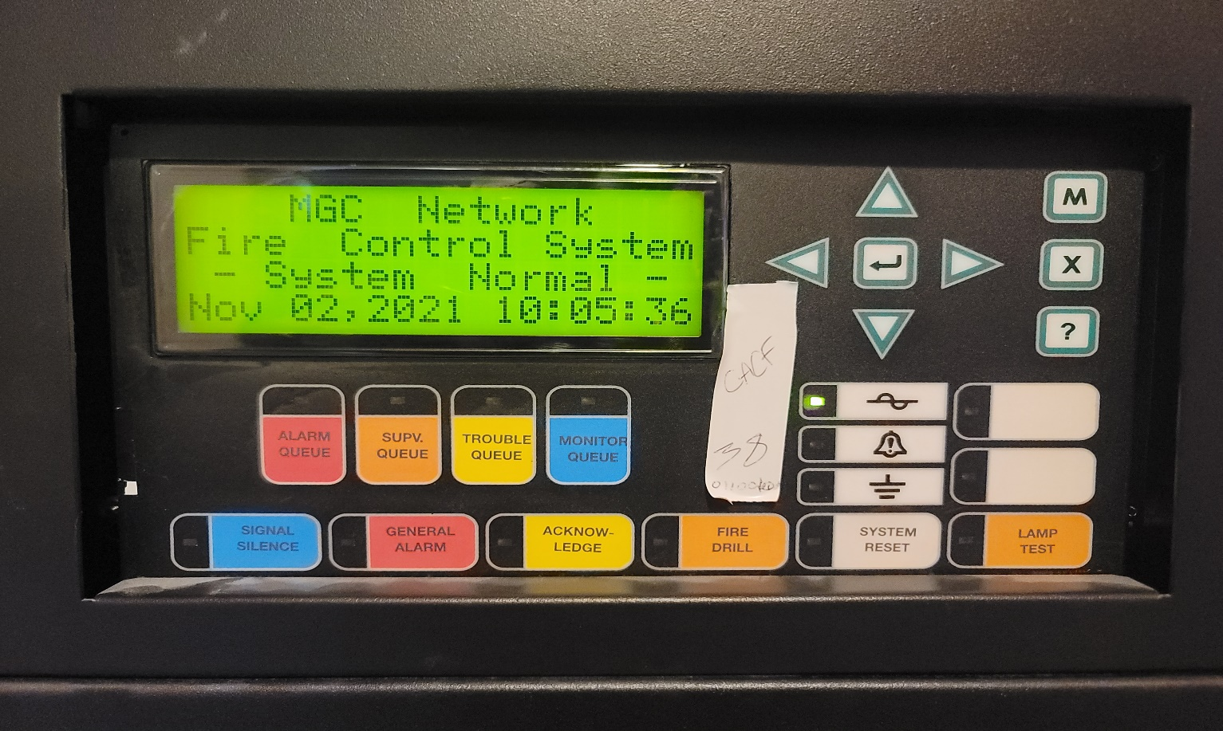

- Press the ACKNOWLEDGE button.
(This will prevent the fire alarm from going to the second stage or evacuation alarm.)

Please note:
The fire alarm system will go to second stage if the ACKNOWLEDGE button is not pressed within 5 minutes.

Step 2- Find the exact location of the Fire Alarm from the fire panel

- Determine fire location by looking at the green digital screen.
- If at the bottom of this green digital screen reads “Alarms 1 of 1” use the info presently on the green digital screen as your Fire location to announce.

If at the bottom of the green digital screen it reads “Alarm 1 of 2 “or “Alarm 1 of 3’ push the Alarm button under the green digital screen and then push the arrow button pointing down (located on your left beside the green digital screen) until it shows “Alarm 1 of 1” this will show where the fire alarm first started. Then use the info that is NOW on the green digital screen as to where the fire alarm has been activated.

Step 3 - Making an Announcement at Faith Manor
(Using the Voice Communication System)
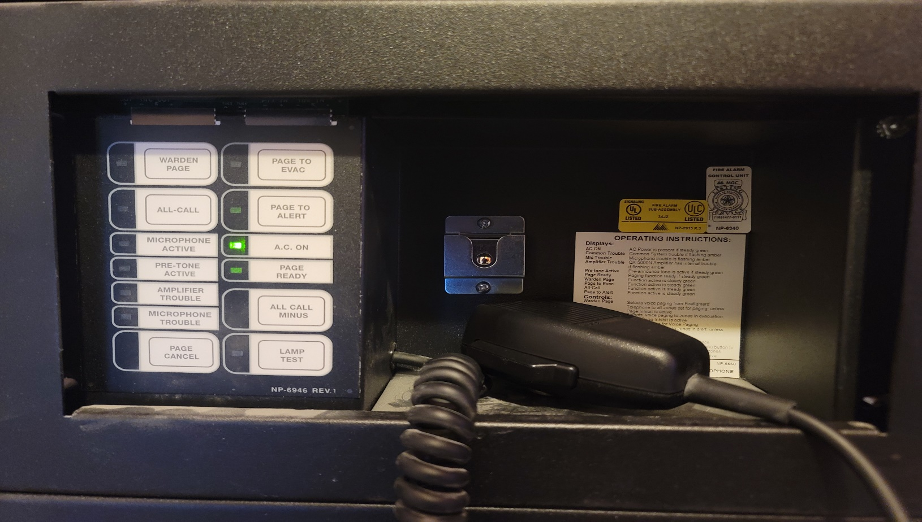

- Press the ALL CALL button.
- Grab the black voice communication system microphone and remove it from its hanger by sliding it upwards.
- Press and hold the black voice communication system microphone button.
- Wait for all speaker zone LED lights to turn on and three beeping sound before making your announcement.
(This will ensure the all speakers and amplifiers are on in all locations and you are ready to make an announcement.).
- Read and announce the fire alarm location indicated on the green display screen. Speak slowly and clearly with 3 inches of space from your mouth to the microphone.

Make the following announcements:
Attention! Attention! Code Red has been activated at ____________ (location indicated on the green display screen) x3

Keep Everyone Updated on the voice communication system and two-way radio on channel #1 every 5 minutes or when a new important information becomes available.

If the fire alarm is for an extended period.

Make the following announcements:
Attention! Attention! The Brampton Fire Department is continuing to investigate and we will keep you informed.

If the incident is a Confirmed Emergency by the Charge RN/RPN/Fire Department/Facilities Staff

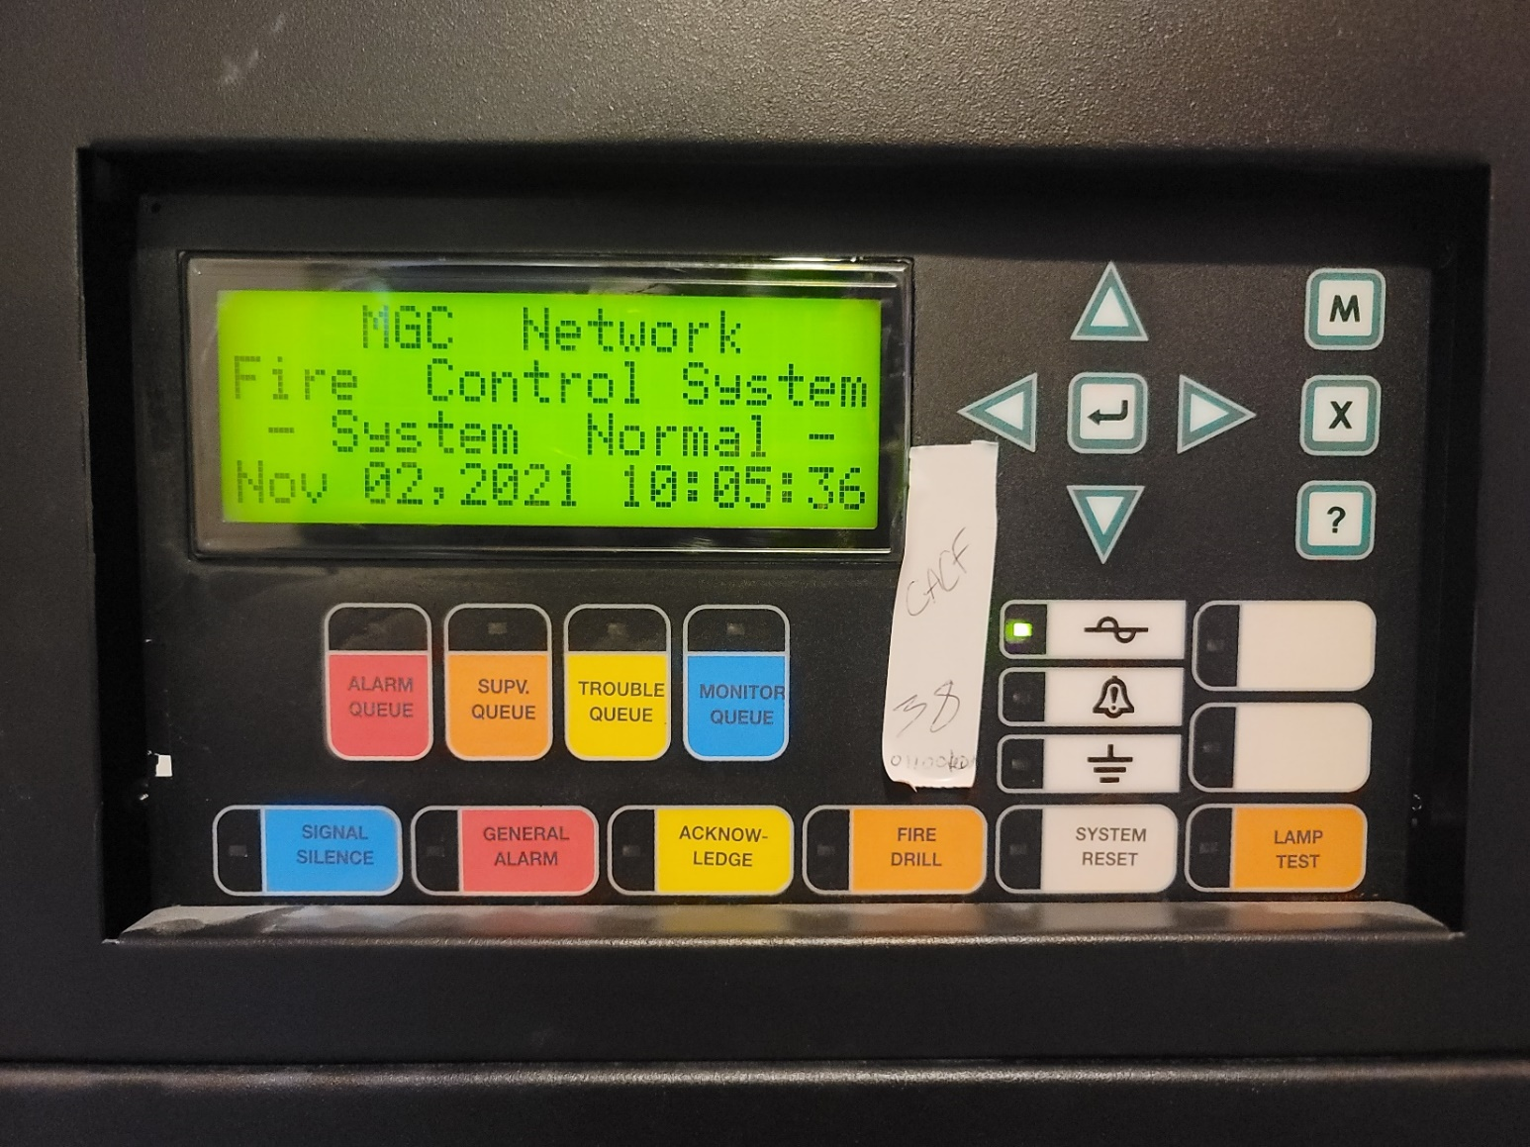

- Press the GENERAL ALARM button.
(This will turn the fire alarm to second stage or evacuation alarm.)

- Make the following announcements on the voice communication system and to all staff on the two-way radio on channel #1:

The Fire alarm on the _____ floor (or area) has been confirmed as emergency. All occupants prepare for Code Green evacuation of the building. (Repeat this three times)

Ask if additional help is required for evacuating, then send help if needed using the appropriate stairway.

Examples:

If the fire is at 2 South, direct the staff to access the 2nd North Stair
If the fire is at 2 North, direct the staff to access the 2nd South Stair

- Make the following announcement using the emergeny voice communications systems (Fire Panel). Do not use the elevators. Walk to your nearest exit and proceed down the stairs with caution. Listen for further instructions

(For All Emergency Colour Codes Beside Code Red, please use the announcement script charts located at each fire panel)

Step 4 - Resetting the Fire Alarm System
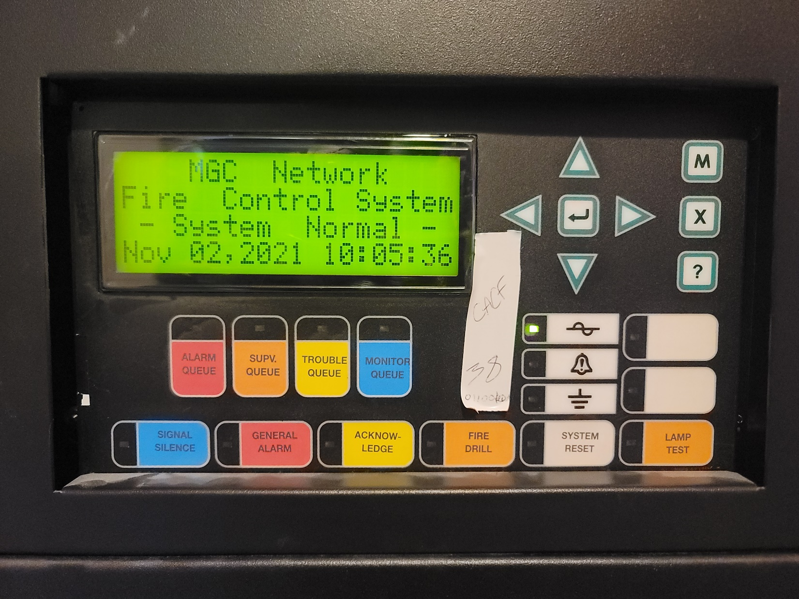

RESET ONLY WITH THE PERMISSION OF THE FIRE DEPARTMENT
- Wait for the permission of the Fire Department to reset the fire alarm system.
- When the Fire Department has given the permission to reset the fire panel, ensure the red pull station has been reset or the smoke has been cleared from the smoke detector.
- Press the silence button.
- Press the SYSTEM RESET.
- When the fire alarm at Faith Manor & Covenant is clear and the system indicates normal.
Make the following announcements to the voice communication system and then to the two-way radio:

Attention! Attention! Code Red, All Clear (Repeat three times)

If the Fire Panel Does Not Reset

SILENCE THE FIRE ALARM ONLY WITH THE PERMISSION OF THE FIRE DEPARTMENT

- Wait for the permission of the Fire Department to silence fire alarm system.
- Press the Alarm Silence button on the fire panel.
- Call the Maintenance and ask to put the system offline and have the fire alarm contractor fix the problem.
- Notify the Emergency Management Coordinator
- Notify Manitenance On-Call

Step 5 - Resetting the Maglocks

(Ensure the maglocks are reset, because this affects the doors in the homes when the fire alarm is activated.)
- Turn the Maglock key switch to the right to the RESET position until you hear a click
- Turn the Maglock key back to the middle position.
- Check that the maglock doors are properly reset and working by testing the doors in the front entrance doors at the home.

Step 6 - Resetting the Elevators
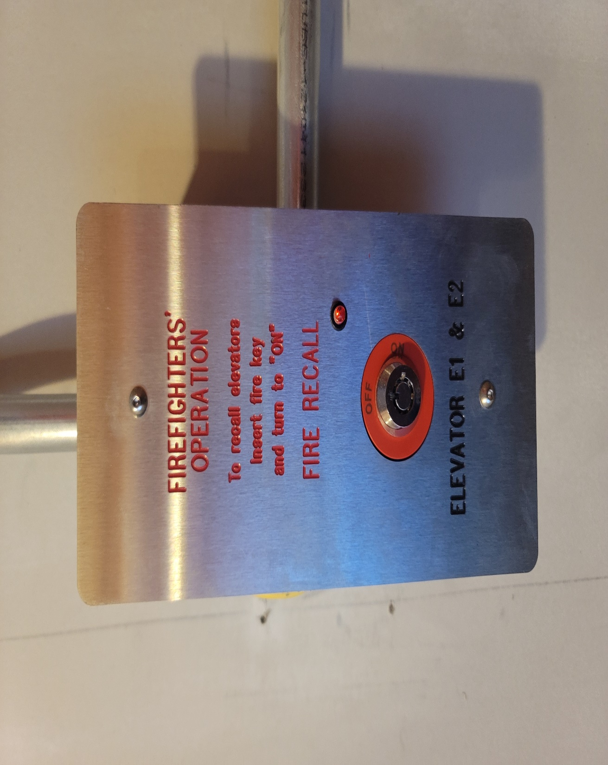

Resetting Elevator – Reset elevator after a fire alarm. Use the elevator keys to reset the elevators. Contact the Janitor for assistance if elevator does not reset.

APPENDIX (E) – Emergency Codes
Codes | Emergency Code Definitions
RED | Fire - Communicate and mobilize a response to protect residents, families, visitors, staff, physicians, and property in the event of smoke and/or fire.
BLUE | Medical Emergency - Provide life support and emergency care.
ORANGE | Community Disaster Response – Activate a response to a community disaster event.
YELLOW | Locate a Missing Resident – Activate a response to locate a missing resident.
WHITE | Workplace Violence - Activate in aggressive/assault situations
PURPLE | Workplace Violence – Activate when there is a hostage-taking situation.
SILVER | Workplace Violence – Activate in aggressive/assault situations with a weapon.
BLACK | Bomb Threat - Activate response to a bomb threat or the discovery of a suspicious package.
BROWN | Hazardous Material Spill - Identify conditions, safely isolate and/or evacuate the area, and protect others from exposure. Perform procedures to be taken in response to a minor or major spill.
GREY | Critical Infrastructure Failure - Activate in instances when there is a gas leak, environmental air issues e.g. smokey air, WIFI downtime, loss of Power, Loss of Water,
GREEN | Evacuation – horizontal, vertical, and total evacuations are activated internally or in a coordinated response effort with external emergency response partners.

APPENDIX (F) – STAFFING PLAN POLICY
HR POLICY and PROCEDURE
Subject/Name | Staffing Plan |  |  | Page 40 of 53
Last Revision Date: |  | April 2018  Revised January 2020  Revised February 1, 2021  Revised February 2022 | Policy #

1 POLICY
  - Holland Christian Homes (HCH) maintains a written staffing plan for all departments in order to provide a staffing complement that is consistent with residents’ care and safety needs balanced with operational demands of the organization.

  - Holland Christian Homes may need to further adjust staffing levels as required in a “confirmed outbreak” or when “under investigation” as required by Public Health or Ministry of Health directives which may change from time to time.

  - The staffing plan sets out the overall organizational structure and scheduling of staff shifts in order to promote continuity of care and all operational needs. The overall structure meets or exceeds the prescribed minimum number of staff in all areas and includes at least the minimum skills and qualifications as prescribed in relevant legislation and HCH Job Descriptions.

  - The staffing plan includes a contingency plan that addresses situations when staff, cannot come to work (for example, including meeting the requirement that there must be one Registered Nurse on duty in the Manors at all times who is a HCH regular staff member or a trained Agency Staff).

  - The staffing plan is evaluated and updated at least annually in accordance with evidence-based practices and, if there are none, in accordance with prevailing practices (applies to the Manors only) and the Fixing Long-Term Care Homes Act requires all Care Communities to have a written staffing plan for the organized programs of nursing services and personal support services.

  - HCH uses agency staff minimally and only when there is no HCH staff available to fill the shift and the shift must be filled to ensure safe resident care.

  - In the Manors, nursing agency staff are used to fill a one to one shift to ensure that our own HCH staff are available to fill the regular scheduled shifts. The only exception would be for our own staff to do a one to one shift when this staff is on modified duties or on any accommodation.

2 PURPOSE
2.01 To minimize the number of different staff members who provide care and services to each resident.

2.02 To balance budgetary demands and the operational needs of the organization.

2.03 To ensure that all staff members are aware of their responsibilities based on schedules that are created, maintained and posted.

2.04 To adhere to HCH’s Mission Statement and Values.

2.05 To adhere to all applicable laws and regulations.
3 SCOPE
3.01 This policy applies to all HCH employees and staff as defined under the Fixing Long Term Care Home Act legislation and all departments.
4 STAFFING SCHEDULES
In Manors, hours are budgeted based on their current CMI and applicable funding.
Mechanisms are in place to adjust to changes in resident acuity and staff replacement needs.

There is at least one Registered Nurse [NOT including the Director of Resident Care (DRC)] on duty in each shift schedule and present at all times. If there is an unexpected absence of situation or is an emergency, ADRC or DRC have to be reachable or available via on-call, the shift may be replaced by the RPN.

Dept/Unit | FTE
POSITIONS
VP of Operations (share with both Grace and Faith Manors) | 0.5 FTE per each home
Administrator | 1
Director of Resident Care (DRC) | 1 (may be on-call when require)
Assistant Director of Resident Care (ADRC) | 1 (may be on-call when require)
Director of Facilities | 1
Housekeeping and Laundry Manager | 1
Dietary Manager | 1
Scheduler | 1
Restorative Care Nurse | 1
Rai Co-ordinator | 1
Behavioural Support Leader | 1
Nurse Practitioner (share with both Grace and Faith Manors) | 0.5 FTE per each home
Director of Programs and Services (Share with both Grace and Faith Manors) | 0.5 FTE per each home

The staffing plan for the Home Area Operations in Faith Manor (160 Beds) and Grace Manor (120 beds) are attached with this policy.

Consistency of Assignment
Consistent Assignments that are fair and equitable based on relative needs for each resident will be implemented and maintained in both Faith and Grace Manors. Nursing staff in full time and part time positions that shadow a full time position or part time in a regular schedule will have a consistent assignment for an extended period of time.

ALTERNATE STAFFING CONTINGENCY PLANS
A Staffing Contingency plan is to be put into operation if needed, especially in case of emergencies, and to allow staff to quickly adapt to changing circumstances to minimize disruption to the delivery of care.
The following templates are used to develop contingency plans for:
- Registered Staff
- PSW

Instructions
- List the potential vacant positions that would require alternate work assignments
- Develop a home-specific plan/strategy to provide directions for what to do if vacant position occurs
- Identify routines/tasks that must be completed despite the staffing compliment for that shift.

Call-in Procedures
List all possible strategies that are to be used to replace the vacant shift and the strategies that are to be implemented to provide resident care. For example:
- Initiate Call in Roster as per collective agreement, if applicable
- Extend Shifts/Double Shifts/12 hours Shift Schedule
- Reassign work assignments i.e. If trained as PSW but works in housekeeping etc.
- Utilize Agency

List all duties that must be done regardless if working with full compliment. Following are examples includes but is not limited to:
- Residents dressed appropriately
- Continence Care
- Repositioning
- Medications
- Treatments
- Nutrition/Hydration
- Restriction of large activities
- Cross train other staff to assist with meals/nourishments
Registered Staff  Vacant Position | Vacant Shift | Plan/Strategy | Duties that must be done
1 Registered Nurse | Days | - Call all available RNs  - Ask RN to stay later  - Ask RN to come in early  - Replace with Agency or ADRC  - Replace with RPN (as long as ADRC or DRC is in building)  - DRC if necessary  - Re-assignment of Registered Staff onsite to cover all units | - In-Charge duties as assigned  - Resident assessment and documentation of high risk issues (i.e. Falls, injuries, change in conditions)  - Medications  - Treatments
 | Evenings | - Call all available RNs  - Ask RN to stay later  - Ask RN to come in early  - Replace with Agency or ADRC  - Replace with RPN (as long as ADRC or DRC is in building)  - DRC if necessary  - Re-assignment of Registered Staff onsite to cover all units | - In-Charge duties as assigned  - Resident assessment and documentation of high risk issues (i.e. Falls, injuries, change in conditions)  - Medications  - Treatments
 | Nights | - Call all available RNs  - Ask RN to stay later  - Ask RN to come in early  - Replace with RPN  - Replace with Agency or ADRC  - DRC if necessary  - Re-assignment of Registered Staff onsite to cover all units | - In-Charge duties as assigned  - Resident assessment and documentation of high risk issues (ie. Falls, injuries, change in conditions)  - Medications  - Treatments
3 and Above vacant Registered Nurses | Days/Evenings | - Call all available RNs  - Ask RN to stay later  - Ask RN to come in early  - Replace with Agency or ADRC  - Replace with RPN  - DRC if necessary  - Re-assignment of Registered Staff onsite to cover all units | - Potential of having RPN assigned as in-charge to take PHONE for emergencies.  - ADRC/DRC to be available via on-call phone in the event that there is an emergency.  - On-call manager to be available to come and support if necessary any non-clinical duties as needed
2 Registered Nurses | Nights | - Call all available RNs  - Ask RN to stay later  - Ask RN to come in early  - Replace with Agency or ADRC  - Replace with RPN  - DRC if necessary  - Re-assignment of Registered Staff onsite to cover all units | - Potential of having RPN assigned as in-charge to take PHONE for emergencies.  - ADRC/DRC to be available via on-call phone in the event that there is an emergency.  - On-call manager to be available to come and support if necessary any non-clinical duties as needed
Registered Practical Nurse | Days | - Call all available RPNs  - Ask RPN to stay later  - Ask RPN to come in early  - Replace with RAI-Coordinator RPN  - Replace with BSO RPN  - Have RPN cover two units with additional PSW staff called in to support (in FM only)  - Replace with RN, if Charge RN – utilize ADRC or DRC as Charge Nurse  - Replace with Agency  - Re-assignment of Registered Staff onsite to cover all units | - In-Charge duties as assigned  - Resident assessment and documentation of high risk issues (ie. Falls, injuries, change in conditions)  - Medications  - Treatments
 | Evenings | - Call all available RPNs  - Ask RPN to stay later  - Ask RPN to come in early  - Replace with RAI-Coordinator RPN  - Replace with BSO RPN  - Have RPN cover two units with additional PSW staff called in to support (in FM only)  - Replace with RN, if Charge RN – utilize ADRC or DRC as Charge Nurse  - Replace with Agency  - Re-assignment of Registered Staff onsite to cover all units | - In-Charge duties as assigned  - Resident assessment and documentation of high risk issues (ie. Falls, injuries, change in conditions)  - Medications  - Treatments
 | Nights | - Call all available RPNs  - Ask RPN to stay later  - Ask RPN to come in early  - Replace with RAI-MDS RPN  - Replace with BSO RPN  - Have RPN cover one additional unit (In FM only) with additional PSW staff called in to support  - Replace with RN, if Charge RN – utilize ADOC or DOC as Charge Nurse if necessary  - Replace with ADOC or Agency  - Re-assignment of Registered Staff onsite to cover all units
3 and above vacant Registered Practical Nurses | Days/Evenings | - Call all available RPNs  - Ask RPN to stay later  - Ask RPN to come in early  - Replace with RAI-MDS RPN  - Replace with BSO RPN  - Replace with RN’s  - Utilize ADRC or DRC as Charge Nurse  - Replace with Agency  - Re-assignment of Registered Staff onsite to cover all units | - ADRC/DRC to be called in  - On-call manager to be available to come and support if necessary any non-clinical duties as needed
2 Registered Practical Nurses | Nights | - Call all available RPNs  - Ask RPN to stay later  - Ask RPN to come in early  - Replace with RAI-MDS RPN  - Replace with BSO RPN  - Replace with RN, if Charge RN – utilize ADRC or DRC as Charge Nurse  - Replace with Agency  - Re-assignment of Registered Staff onsite to cover all units  - RN in building to cover all units | - ADOC/DOC to be called in and if unable to MUST be available via phone in the event that there is an emergency.  - On-call manager to be available to come and support if necessary any non-clinical duties as needed

PSW  Vacant Position | Vacant Shift | Plan/Strategy | Duties that must be done (home-specific)
1 or 2 vacant PSW | Days and Evenings | - Call all available PSW as per CA  - Bring staff in early or stay late  - Pull from 1:1 and call agency for coverage of 1:1  - Reassign staff i.e. Bath shift to reg. shift  - Reassign Residents to available PSWs  - Reassign PSW from another floor as needed then reassign residents to other PSW  - Partner up with other unit/wing to provide assistance with showers and meals Utilize support from multidisciplinary team (i.e. Activation Staff for meal service assistance and portering)  - Registered staff to assist with care requirements | - Provide supervision and/or assistance to the residents in the activities of daily living including eating, dressing, transferring, toileting, hygiene, grooming and bathing
3 vacant PSW |  | - Call all available PSW as per CA  - Bring staff in early or stay late  - Reassign staff  - Pull 1:1 as available, call agency to cover  - Reassign Residents to available PSWs  - Pull short shifts  - Call Agency  - Utilize support from multidisciplinary team (i.e. Rec Staff for meal service assistance and portering)  - Leadership team members to assist where able (meals/portering/spotting transfers/independent residents/monitoring)  - Call Agency | - Provide supervision and/or assistance to the residents in the activities of daily living including eating, dressing, transferring, toileting, hygiene, grooming and bathing
1 or 2 vacant PSW | Nights | - Call all available PSW as per CA  - Bring staff in early or stay late  - Pull 1:1 and call agency for 1:1  - Reassign staff  - Reassign Residents to available PSWs  - Registered staff to assist with care  - Call Agency | - Provide supervision and/or assistance to the residents in the activities of daily living including transferring, toileting, hygiene, repositioning and grooming
3 vacant PSW |  | - Call all available PSW/HCA/NA  - Pull 1:1 and call agency to cover 1:1  - Bring staff in early or stay late  - Reassign staff  - Reassign Residents to available PSWs  - Registered staff to assist with care  - Call in an additional RPN  - Manager on call (eg Administrator), ADRC, or DRC to come in for support as needed  - Call Agency | - Provide supervision and/or assistance to the residents in the activities of daily living including transferring, toileting, hygiene, repositioning and grooming
Program Evaluation
Review and evaluation of the staffing plan must be completed annually.

ATTACHMENTS
- Each Department Regular and Emergencies Staffing Patterns

APPENDIX (G) – Staff Contact List

Holland Christian Homes staff contact list will be kept confidential at all times. Only staff with a signed Confidential agreement in an active emergency will have access to this list. This list is used to conduct annual fan out tests and to call staff to duty during an emergency. This list is updated on a monthly basis and is kept online with a backup in the Emergency Management

APPENDIX (H) – Sample Supply List for Holland Christian Homes EOC
Below is a sample list of items needed to activate the Command Center/EOC location:

Communication Equipment
- Cellular phone
- Analog phone
- Telephones: handsets, lines, switchboard
- Public address system (Fire Panel)
- Two-way radio

Electronic Equipment
- Weather radio – hand cranked or battery operated
- Fax machine
- Copy machine
- Television/Cable/Satellite Service
- Laptops/computer terminals
- Printer/scanner
- Overhead projector with screen
- Surge protectors
- Digital camera

Food and Water
- Bottled water and shelf-stable food

Reference and Resource Materials
- Vendor contact list
- Staff contact list
- Insurance Information
- External Partner contact list
- Emergency management plan
- IMS Forms/Notebooks to record EOC activities
- Business Continuity Plan
- Reference materials (blueprints, maps, facility policy and procedure manuals)

Furniture
- Tables and chairs
- Flip chart, easel & pad
- White boards and markers
- Bulletin board

Office Supplies
- Miscellaneous office supplies (i.e., staplers, staples, staple removers, envelopes of various sizes, paper clips, push pins, masking/scotch tape, pencils, pens in assorted colors, assorted rubber bands, binders, writing pads, note pads, name tags, markers)
- Batteries for equipment

Safety Equipment and Supplies
- Flashlights, headlamps & batteries
- Light sticks
- First aid kit
- Cleaning wipes
- Hand sanitizer
- Duct tape

Personal Protective Equipment (PPE)
- Face shields
- N95 respirators
- Disinfecting wipes
- Surgical masks
- Nitrile glove
- Gowns
- Boot Covers

APPENDIX (I) – Sample Vendor Contact List
The Vendor contact list is utilized when needed and is maintained by the Maintenance Department. This information is considered confidential and will not be posted online. Template below is the template used to organize the contact list.
Vendor Name | Description | Contact Person | Phone/ Email | Contract/  Account #

APPENDIX (J) - Sample Multi-year Training and Exercise Plan
The purpose of this plan (sample below) is to document Holland Christian Homes’s overall training and exercise program priorities for a specific period. Instructions for use:
- Enter all the participating sites/departments, coalitions, or community partners on the left side of the schedule.
- Enter training and exercises by month indicating the title and type of training or exercise and intended audience.
YEAR _2024___
Buildings/Floor | Jan | Feb | Mar | Apr | May | Jun | Jul | Aug | Sep | Oct | Nov | Dec
Bethany Place |  |  |  |  | Code Red | Code Red Fire Panel | Code Green Horizontal | Code Yellow/ | Code Red Fire Panel | Code Orange Fan out/Call back. | Code White
Faith Manor |  |  |  |  | Code Red Fire Panel | Code Blue | Code Yellow | Code Orange Fan out/Call back. | Code Green Vertical | Code Black | Code White
 |  |  |  |  |  |  | Exercise
Ebenezer Centre |  |  |  |  |  |  | Code Black | Code Red Table Top
Grace Manor |  |  |  |  | Code Red Fire Panel | Code Red Fire Panel | Code Yellow/ | Code Blue | Code Black | Code Orange Fan Out Call | Code White
Fire Drill | All Sites |  |  |  | Fire Drill | Fire Drill | Fire Drill | Fire Drill | Fire Drill | Fire Drill | Fire Drill | Fire Drill

INTENTIONALLY LEFT BLANK
DO NOT REMOVE

