Sunday | Monday | Tuesday | Wednesday | Thursday | Friday | Saturday
25 | 26 | 27 | 28 | 29 | 1 | 2

Towers Activities Weekly Calendar
10am Church Service- Heritage Hall  4:30pm Nederland’s Zingt – Ch.990  7pm Church Service – Heritage Hall  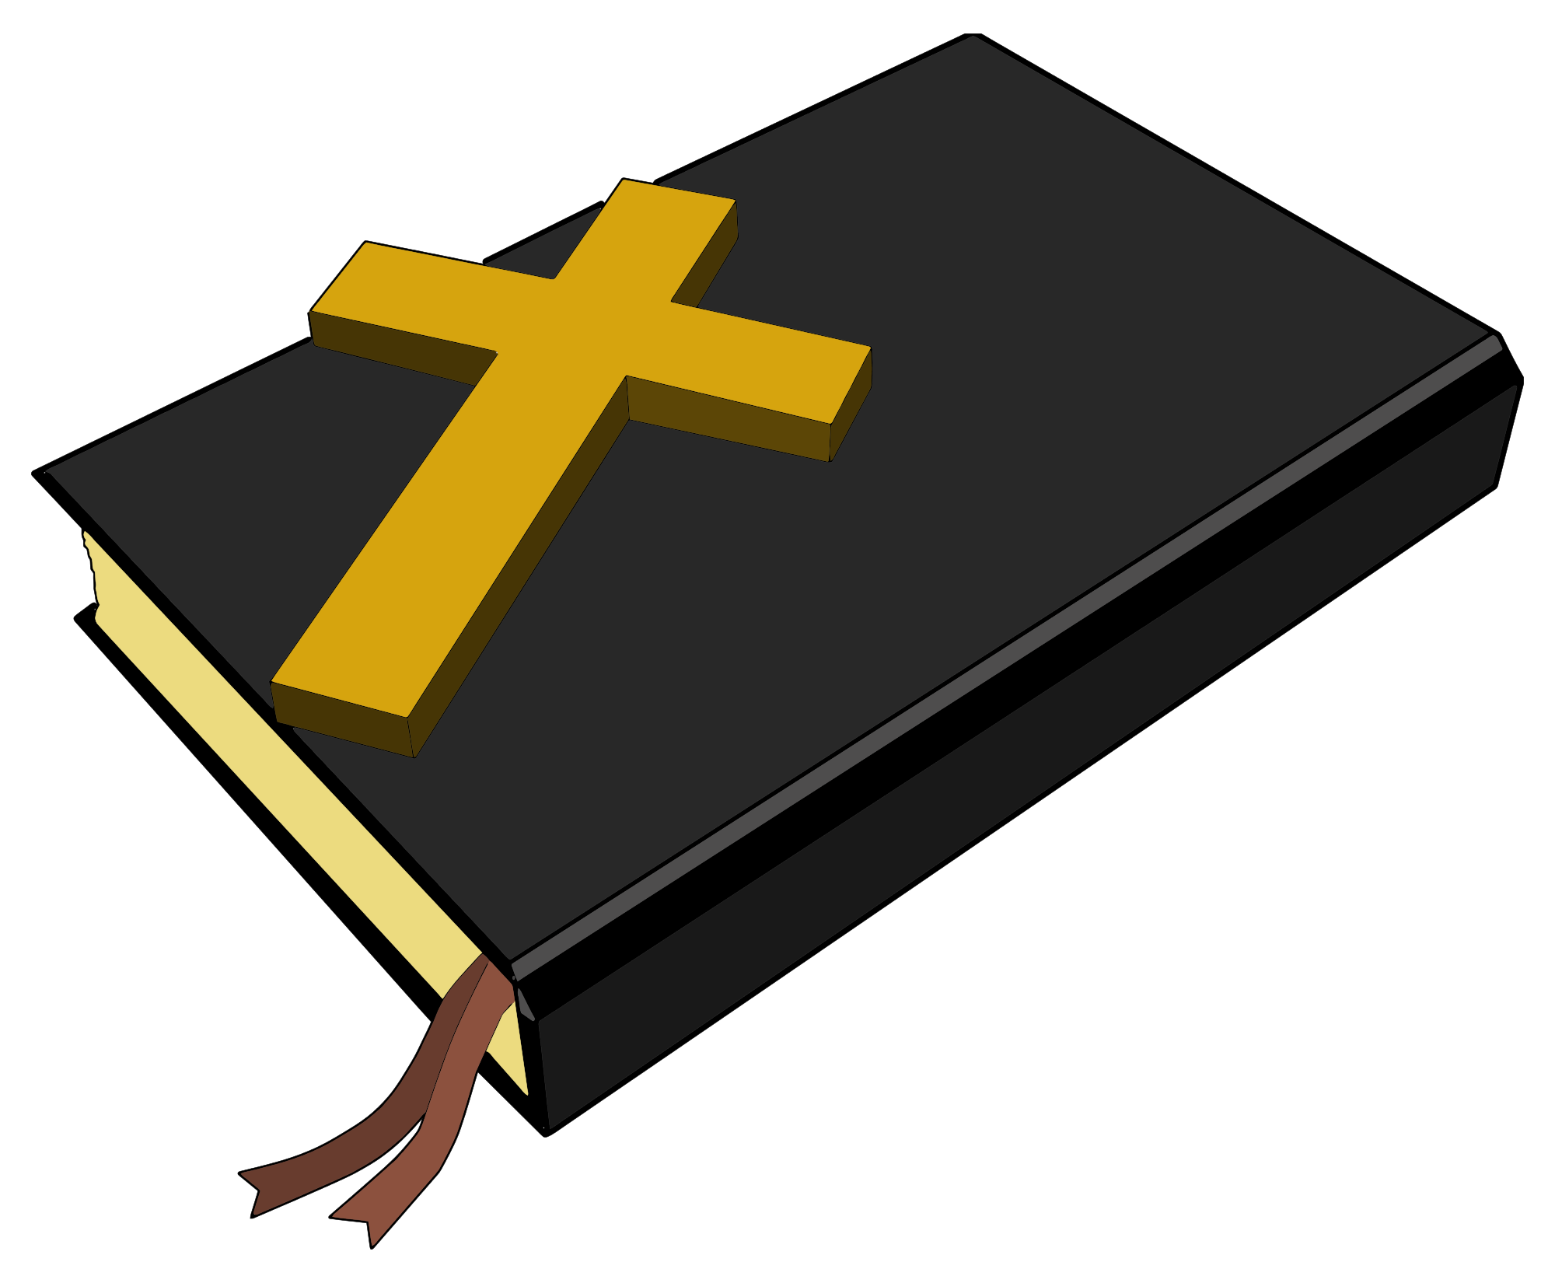  Index: TT = Trinity Tower  KT = King Tower  PT = Providence Tower  CT = Covenant Tower  HT = Hope Tower  PcT = Peace Tower  HeH = Heritage Hall  HaH = Harmony Hall  HoH = Horizon Hall  Italics = CH990  Underline = Towers Nursing Office | 10am Roman Catholic Mass – Harmony Hall  10:30am Peace Tower Coffee Social – Horizon Hall  2pm- Bingo! – Harmony Hall  7pm Sing Out! – Heritage Hall | 9:30am Devotions Ch.990  10am Hope & Trinity Coffee Social – Harmony Hall  11am Fun + Fitness - Heritage Hall  1pm Bridge Club – KT Library  2:30pm Covenant Tower Coffee Social- Covenant Tower Lounge  6:30pm Bid Euchre – PT Meeting Room | 9am Busy Hands – Trinity Tower Meeting Room  10am Chapel – Horizon Hall  1:30pm Cribbage Club – PT Meeting Room  1:30pm Art Expressions – Trinity Tower Meeting Room  2pm Operation Mercy Yarn Pick up – Harmony Hall | 9:30am Devotions  Ch. 990  10am Tai Chi – Horizon Hall  1pm Klaverjassen – KT Library  2pm Prayer Shawl Group – CT Lounge  Donation - $2  2pm Line Dancing w/ Liz – Horizon Hall  7pm KTEE Euchre – Horizon Hall | 11am Fun + Fitness - Heritage Hall  $5- Pay at door  11am Yoga with Kathleen Osmond – Horizon Hall  7pm Board Games Night – Horizon Hall  7pm Bingo! – Harmony Hall | 10am King Tower Coffee Social – Horizon Hall  10am – Providence Tower Coffee Social – PT Meeting Room  
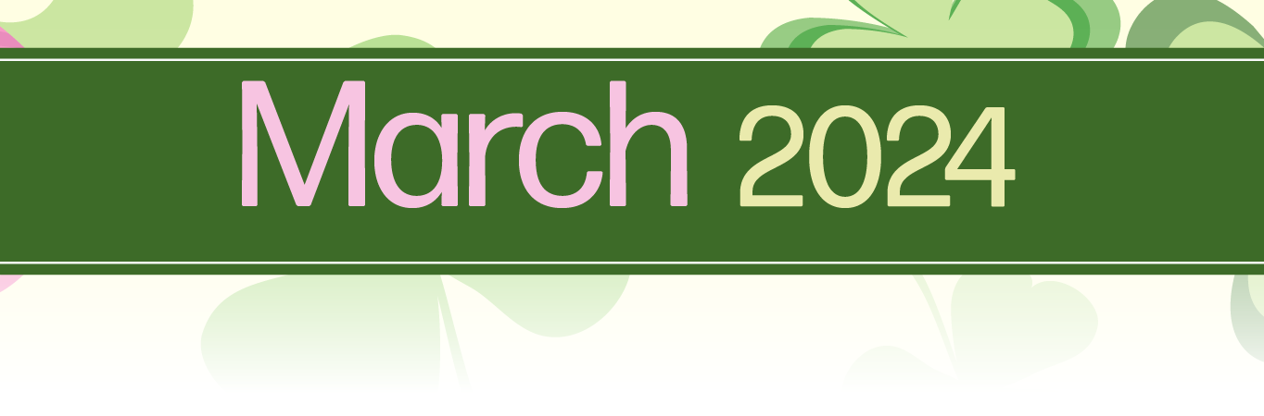

HCH Towers Activities
Sunday | Monday | Tuesday | Wednesday | Thursday | Friday | Saturday
3 | 4 | 5 | 6 | 7 | 8 | 9

Towers Activities Weekly Calendar
10am Church Service- Heritage Hall  4:30pm Nederland’s Zingt – Ch.990  7pm Church Service – Heritage Hall  Index: TT = Trinity Tower  KT = King Tower  PT = Providence Tower  CT = Covenant Tower  HT = Hope Tower  PcT = Peace Tower  HeH = Heritage Hall  HaH = Harmony Hall  HoH = Horizon Hall  Italics = CH990  Underline = Towers Nursing Office | 10am Roman Catholic Mass – Harmony Hall  10:30am Peace Tower Coffee Social – Horizon Hall  11am Armchair Travels “Vienna” – Ch. 990  2pm- Bingo! – Harmony Hall  7pm Sing Out! – Heritage Hall | 9:30am Devotions Ch.990  10am Hope & Trinity Coffee Social – Harmony Hall  10am Vendor: Red Touch Studio – Outside Heritage Hall  11am Fun + Fitness - Heritage Hall  1pm Bridge Club – KT Library  2:30pm Covenant Tower Coffee Social- Covenant Tower Lounge  6:30pm Bid Euchre – PT Meeting Room | 8:30am Foot Care Clinic – TNO Nursing Station  9am Busy Hands – Trinity Tower Meeting Room  10am Chapel – Horizon Hall  1:30pm Cribbage Club – PT Meeting Room  1:30pm Art Expressions – Trinity Tower Meeting Room  2pm Operation Mercy Yarn Pick up – Harmony Hall | 9:30am Devotions  Ch. 990  10am Tai Chi – Horizon Hall  1pm Klaverjassen – KT Library  1:30pm Movie Matinee – Heritage Hall  2pm Prayer Shawl Group – CT Lounge  Donation - $2  2pm Line Dancing w/ Liz – Horizon Hall  7pm KTEE Euchre – Horizon Hall | Sign-up Event  10am Cooking Demo – Harmony Hall  11am Fun + Fitness - Heritage Hall  7pm Board Games Night – Horizon Hall  7pm Bingo! – Harmony Hall | 10am King Tower Coffee Social – Horizon Hall  10am – Providence Tower Coffee Social – PT Meeting Room
HCH Towers Activities
Sunday | Monday | Tuesday | Wednesday | Thursday | Friday | Saturday
10 | 11 | 12 | 13 | 14 | 15 | 16

Towers Activities Weekly Calendar

10am Church Service- Heritage Hall  4:30pm Nederland’s Zingt – Ch.990  7pm Church Service – Heritage Hall  Index: TT = Trinity Tower  KT = King Tower  PT = Providence Tower  CT = Covenant Tower  HT = Hope Tower  PcT = Peace Tower  HeH = Heritage Hall  HaH = Harmony Hall  HoH = Horizon Hall  Italics = CH990  Underline = Towers Nursing Office | 10am Roman Catholic Mass – Harmony Hall  10:30am Peace Tower Coffee Social – Horizon Hall  2pm- Bingo! – Harmony Hall  7pm Sing Out! – Heritage Hall  Sign-Up Event    7pm Paint Night- Harmony Hall | 9:30am Devotions Ch.990  $5- Pay at door  10am Music & Movement- Horizon Hall  10am Hope & Trinity Coffee Social – Harmony Hall  10am Vendor: Traditions Alive- Outside Heritage Hall  11am Fun + Fitness - Heritage Hall  1pm Bridge Club – KT Library  2:30pm Covenant Tower Coffee Social- Covenant Tower Lounge  6:30pm Bid Euchre – PT Meeting Room | 9am Busy Hands – Trinity Tower Meeting Room  10am Chapel – Horizon Hall  1:30pm Cribbage Club – PT Meeting Room  1:30pm Art Expressions – Trinity Tower Meeting Room  2pm Operation Mercy Yarn Pick up – Harmony Hall | 9:30am Devotions  Ch. 990  10am Tai Chi – Horizon Hall  10am Vendor: Mobile Senior Shop- Heritage Hall  1pm Klaverjassen – KT Library  2pm Prayer Shawl Group – CT Lounge  Donation - $2  2pm Line Dancing w/ Liz – Horizon Hall  7pm KTEE Euchre – Horizon Hall | 11am Fun + Fitness - Heritage Hall  $5- Pay at door  11am Yoga with Kathleen Osmond – Horizon Hall  2pm Finnegan’s school of Irish Dance Performance – Heritage Hall  7pm Board Games Night – Horizon Hall  7pm Bingo! – Harmony Hall | 10am King Tower Coffee Social – Horizon Hall  10am – Providence Tower Coffee Social – PT Meeting Room
HCH Towers Activities
Sunday | Monday | Tuesday | Wednesday | Thursday | Friday | Saturday
17 | 18 | 19 | 20 | 21 | 22 | 23

Towers Activities Weekly Calendar

Happy St. Patrick’s Day  10am Church Service- Heritage Hall  4:30pm Nederland’s Zingt – Ch.990  7pm Church Service – Heritage Hall  Index: TT = Trinity Tower  KT = King Tower  PT = Providence Tower  CT = Covenant Tower  HT = Hope Tower  PcT = Peace Tower  HeH = Heritage Hall  HaH = Harmony Hall  HoH = Horizon Hall  Italics = CH990  Underline = Towers Nursing Office | 10am Roman Catholic Mass – Harmony Hall  10:30am Peace Tower Coffee Social – Horizon Hall  11am Tune into Tunes “Toronto Sinfonia” – Ch. 990  2pm- Bingo! – Harmony Hall  7pm Sing Out! – Heritage Hall | 9:30am Devotions Ch.990  10am Hope & Trinity Coffee Social – Harmony Hall  11am Fun + Fitness - Heritage Hall  1pm Bridge Club – KT Library  1:30pm Speakers Corner “Arthur Boers” – Harmony Hall  2:30pm Covenant Tower Coffee Social- Covenant Tower Lounge  6:30pm Bid Euchre – PT Meeting Room  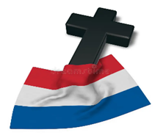  7pm Dutch Evening of Praise – Heritage Hall | 8:30am Foot Care Clinic – TNO Nursing Station  9am Busy Hands – Trinity Tower Meeting Room  10am Chapel – Horizon Hall  1pm Mobility Clinic- TNO Nursing Station  1:30pm Cribbage Club – PT Meeting Room  1:30pm Art Expressions – Trinity Tower Meeting Room  2pm Operation Mercy Yarn Pick up – Harmony Hall | Sign-Up Event  9:15am Out and About Bus Trip  9:30am Devotions  Ch. 990  10am Tai Chi – Horizon Hall  1pm Klaverjassen – KT Library  2pm Prayer Shawl Group – CT Lounge  Donation - $2  2pm Line Dancing w/ Liz – Horizon Hall  7pm KTEE Euchre – Horizon Hall  7pm Movie Night- Heritage Hall | 11am Fun + Fitness - Heritage Hall  $5- Pay at door  11am Yoga with Kathleen Osmond – Horizon Hall  1:30pm Karaoke – Harmony Hall  7pm Board Games Night – Horizon Hall  7pm Bingo! – Harmony Hall  7pm Performance: Duo Concertante -Heritage Hall | 10am King Tower Coffee Social – Horizon Hall  10am – Providence Tower Coffee Social – PT Meeting Room
HCH Towers Activities
Sunday | Monday | Tuesday | Wednesday | Thursday | Friday | Saturday
24 | 25 | 26 | 27 | 28 | 29 | 30

Towers Activities Weekly Calendar

10am Church Service- Heritage Hall  4:30pm Nederland’s Zingt – Ch.990  7pm Church Service – Heritage Hall  Index: TT = Trinity Tower  KT = King Tower  PT = Providence Tower  CT = Covenant Tower  HT = Hope Tower  PcT = Peace Tower  HeH = Heritage Hall  HaH = Harmony Hall  HoH = Horizon Hall  Italics = CH990  Underline = Towers Nursing Office | 10am Roman Catholic Mass – Harmony Hall  10:30am Peace Tower Coffee Social – Horizon Hall  2pm- Bingo! – Harmony Hall  7pm Sing Out! – Heritage Hall | 9:30am Devotions Ch.990  10am Hope & Trinity Coffee Social – Harmony Hall  $5- Pay at door  10am Music & Movement- Horizon Hall  11am Fun + Fitness - Heritage Hall  1pm Bridge Club – KT Library  2:30pm Covenant Tower Coffee Social- Covenant Tower Lounge  6:30pm Bid Euchre – PT Meeting Room  7:30pm Performance: The Crusaders Male Chorus- Heritage Hall | 9am Busy Hands – Trinity Tower Meeting Room  10am Chapel – Horizon Hall  1:30pm Cribbage Club – PT Meeting Room  1:30pm Art Expressions – Trinity Tower Meeting Room  2pm Operation Mercy Yarn Pick up – Harmony Hall  2pm Birthday Party – Heritage Hall | 9:30am Devotions  Ch. 990  10am Tai Chi – Horizon Hall  1pm Klaverjassen – KT Library  2pm Prayer Shawl Group – CT Lounge  Donation - $2  2pm Line Dancing w/ Liz – Horizon Hall  7pm KTEE Euchre – Horizon Hall | Good Friday  10am Good Friday Worship & Communion Service – Heritage Hall  7pm Bingo! – Harmony Hall  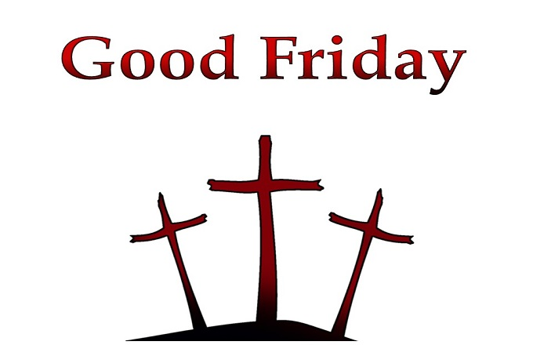 | 10am King Tower Coffee Social – Horizon Hall  10am – Providence Tower Coffee Social – PT Meeting Room
HCH Towers Activities
Sunday | Monday | Tuesday | Wednesday | Thursday | Friday | Saturday
31 | 1 | 2 | 3 | 4 | 5 | 6

Towers Activities Weekly Calendar
Easter Sunday  10am Easter Sunday Church Service- Heritage Hall  4:30pm Nederland’s Zingt – Ch.990  7pm Church Service – Heritage Hall    Index: TT = Trinity Tower  KT = King Tower  PT = Providence Tower  CT = Covenant Tower  HT = Hope Tower  PcT = Peace Tower  HeH = Heritage Hall  HaH = Harmony Hall  HoH = Horizon Hall  Italics = CH990  Underline = Towers Nursing Office | Easter Monday  10am Roman Catholic Mass – Harmony Hall  10:30am Peace Tower Coffee Social – Horizon Hall  7pm Sing Out! – Heritage Hall  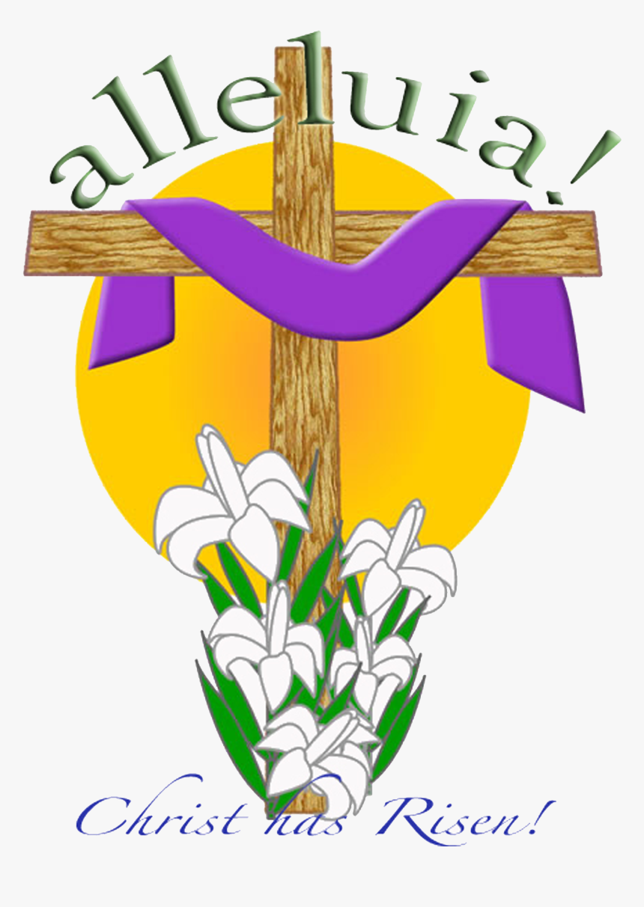 | 9:30am Devotions Ch.990  10am Hope & Trinity Coffee Social – Harmony Hall  11am Fun + Fitness - Heritage Hall  1pm Bridge Club – KT Library  2:30pm Covenant Tower Coffee Social- Covenant Tower Lounge  6:30pm Bid Euchre – PT Meeting Room | 9am Busy Hands – Trinity Tower Meeting Room  10am Chapel – Horizon Hall  1:30pm Cribbage Club – PT Meeting Room  1:30pm Art Expressions – Trinity Tower Meeting Room  2pm Operation Mercy Yarn Pick up – Harmony Hall | 9:30am Devotions  Ch. 990  10am Tai Chi – Horizon Hall  1pm Klaverjassen – KT Library  2pm Prayer Shawl Group – CT Lounge  Donation - $2  2pm Line Dancing w/ Liz – Horizon Hall  7pm KTEE Euchre – Horizon Hall | 11am Fun + Fitness - Heritage Hall  7pm Board Games Night – Horizon Hall  7pm Bingo! – Harmony Hall | 10am King Tower Coffee Social – Horizon Hall  10am – Providence Tower Coffee Social – PT Meeting Room


HCH Towers Activities

